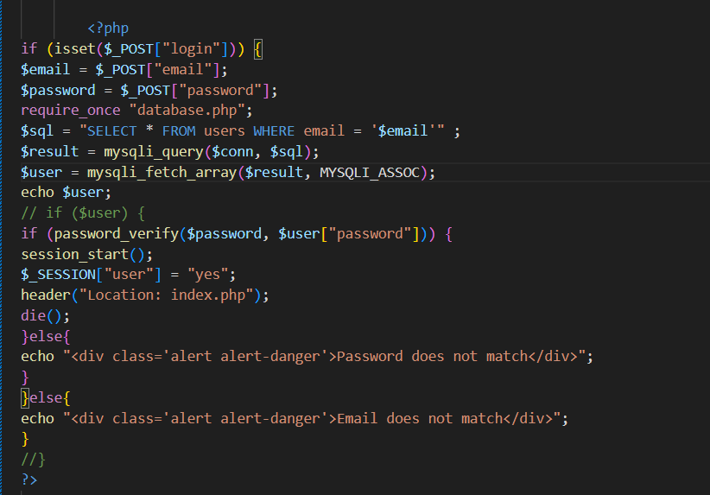

Login is successful even when the password is incorrect.

Name of the variables may be wrong.

Check the logic of the code.

Check what the $user gives as a output.